**AWS DEVELOPER TOOLS BLUE/GREEN DEPLOYMENT**

#Open AWS Management Console

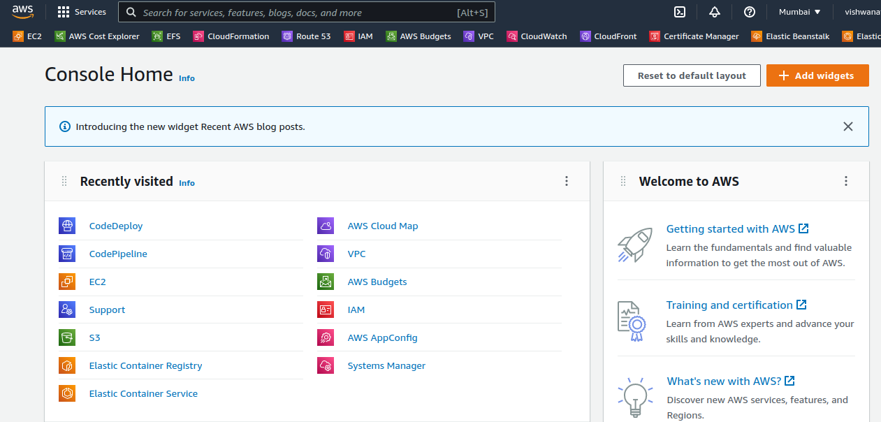

#Search IAM Service

Create Two IAM Role for EC2 Instance & Codedeploy Role

Open IAM Service

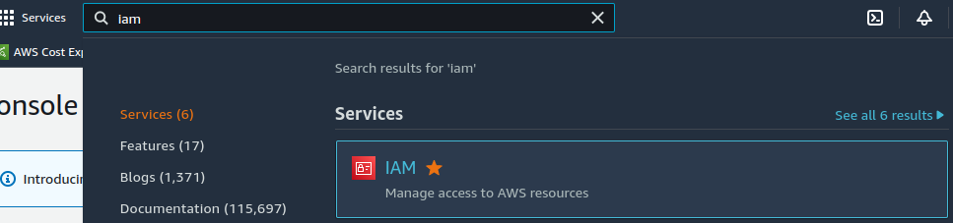

Choose Role

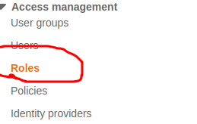

Create Role



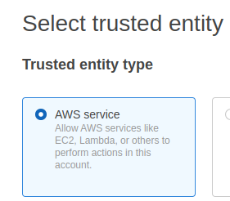

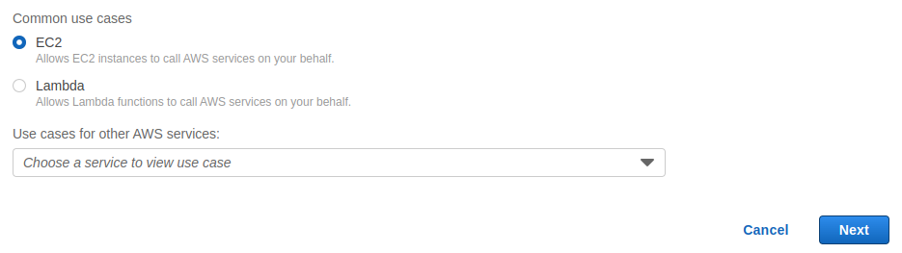

Select Policy









Created Role Punisher with Attached Policy

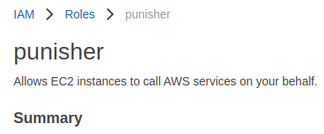

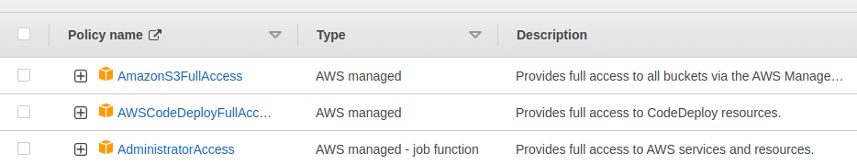

Create Another Role For CodeDeploy

Create Role

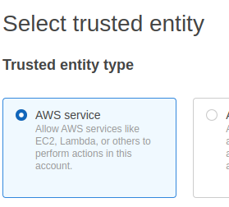

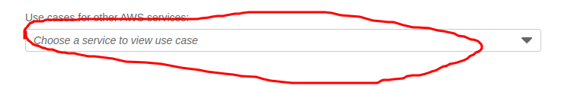

Choose CodeDeploy

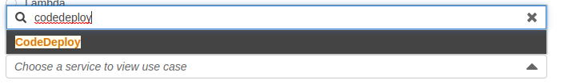

Select CodeDeploy

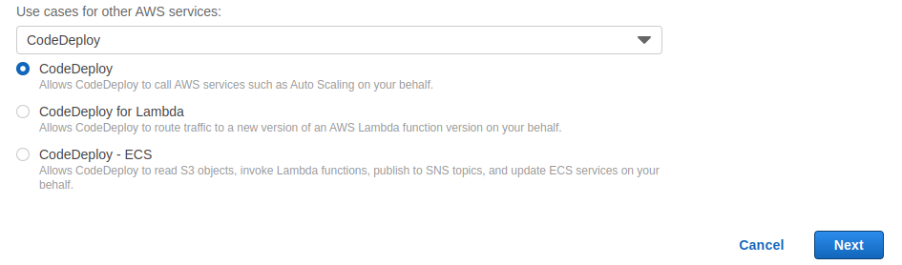

Add permission

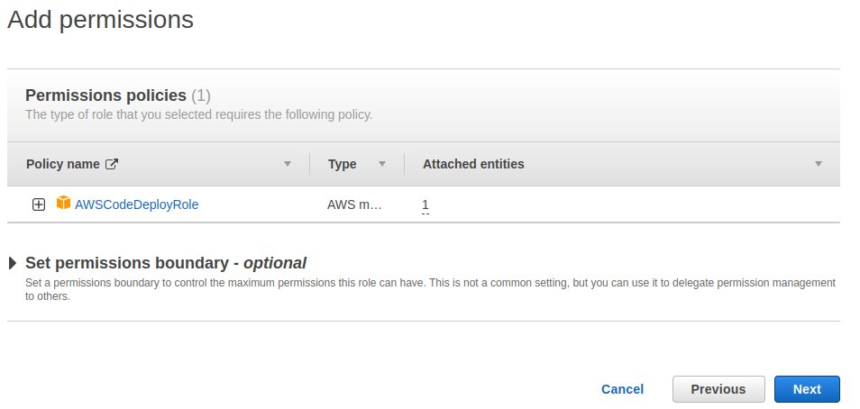

Save Role Name

Create Role

Create Role Flash

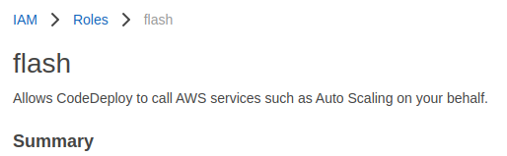

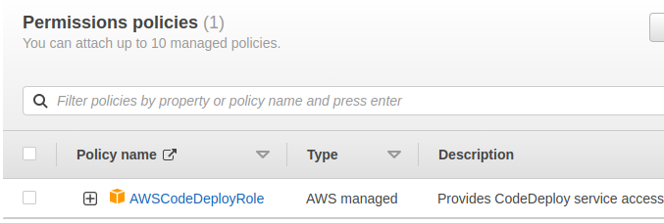

Search EC2 Service on AWS Management Console

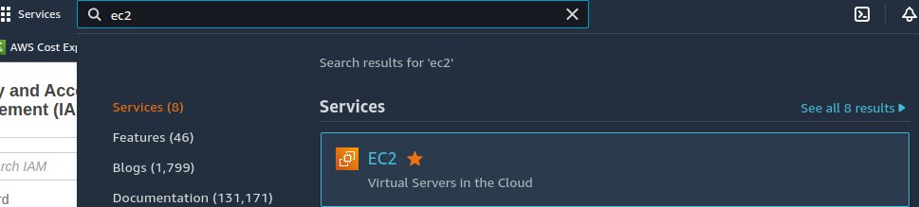

Open EC2 Service

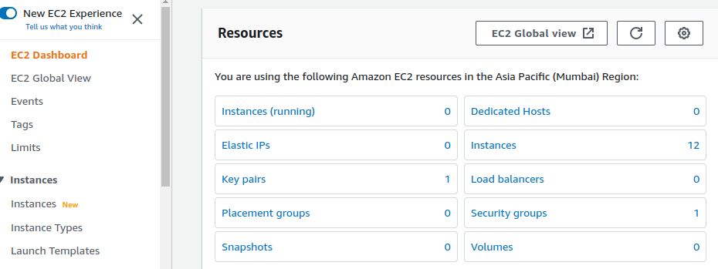

Create Auto Scaling

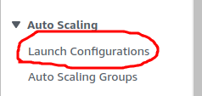

Open Launch Configuration

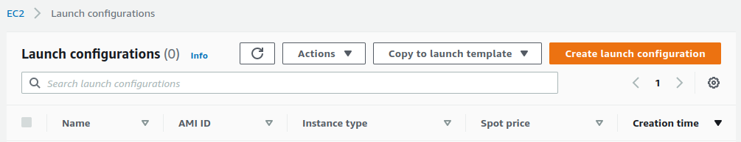

Create Launch Configuration

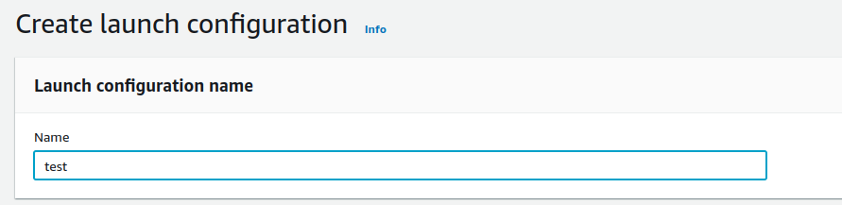

Copy Server AMI-Id & Paste Here

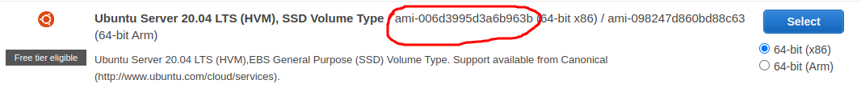

Paste Here

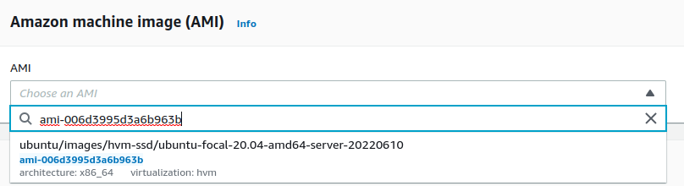

Choose Instance Type

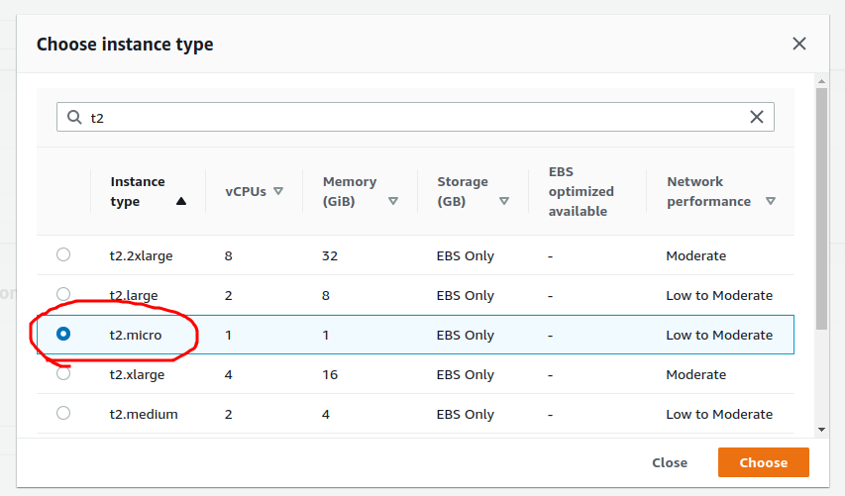

Select IAM Role Which You Created

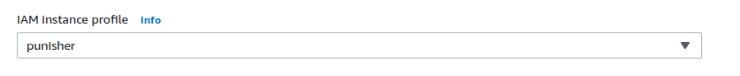

Open Advanced details

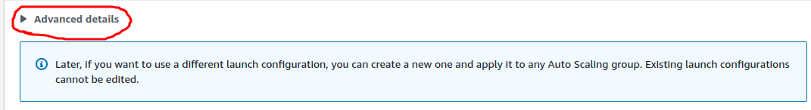

Add user data

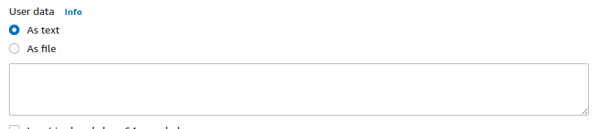

Add this Script

#!/bin/bash -xe

apt update -y

apt install apache2 -y

cd /var/www/html/

rm -rf index.html

echo 'Hello' >> /var/www/html/index.html

systemctl restart apache2

apt-get update

apt-get install -y ruby

wget https://aws-codedeploy-ap-south-1.s3.amazonaws.com/releases/codedeploy-agent_1.0-1.1597_all.deb

dpkg-deb -R codedeploy-agent_1.0-1.1597_all.deb codedeploy-agent_1.0-1.1597_ubuntu20

sed 's/2.0/2.7/' -i ./codedeploy-agent_1.0-1.1597_ubuntu20/DEBIAN/control

dpkg-deb -b codedeploy-agent_1.0-1.1597_ubuntu20

dpkg -i codedeploy-agent_1.0-1.1597_ubuntu20.deb

systemctl start codedeploy-agent

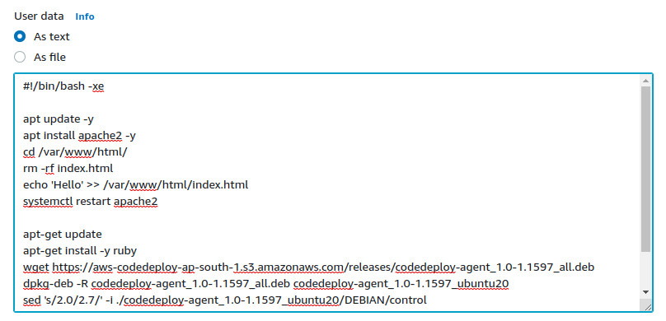

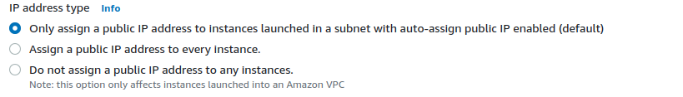

Select Security Group

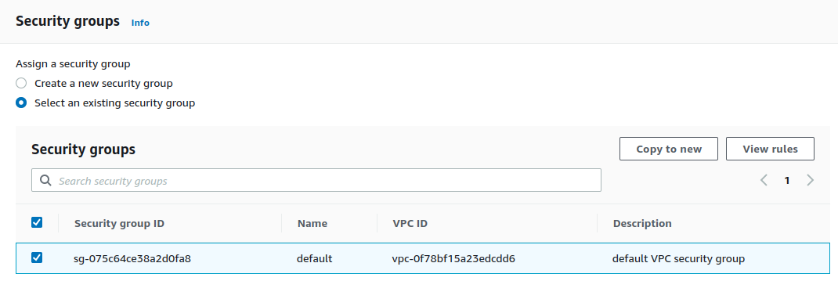

Choose Keys

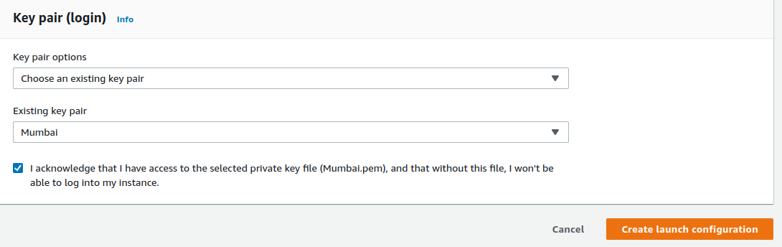

Launch Configuration Created

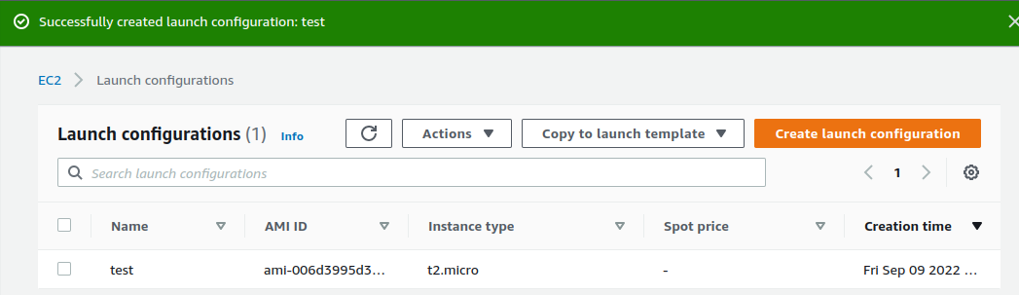

Open Auto Scaling Group

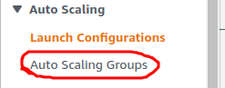

Create Auto Scaling Group

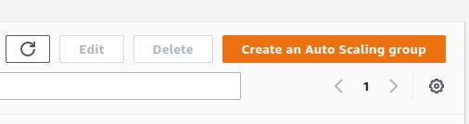

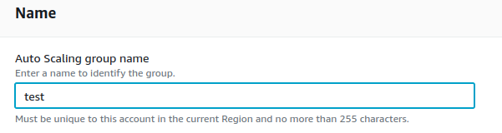

Switch to Launch Configuration



Choose Launch Configuraion Name

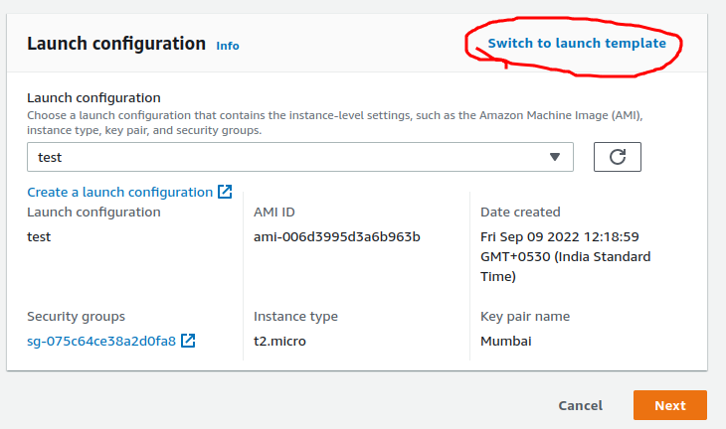

Choose vpc Subnet

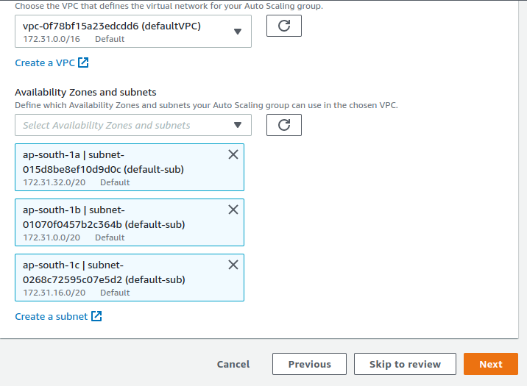

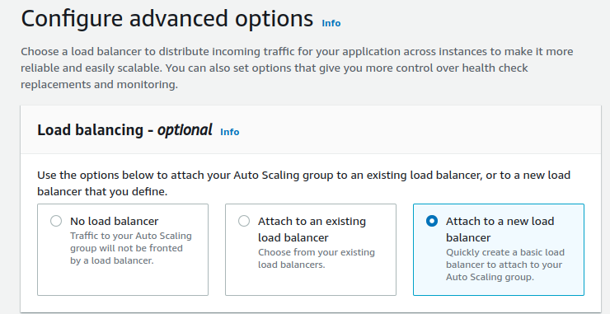

Attach Load Balancer

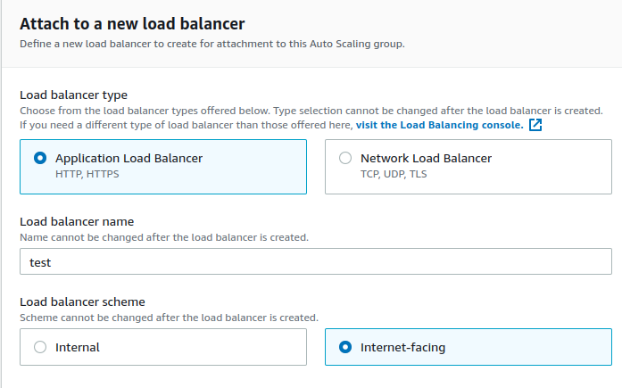

Add Target Group

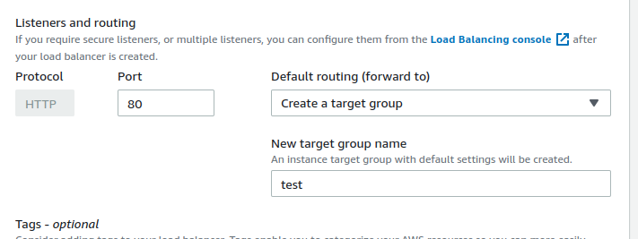



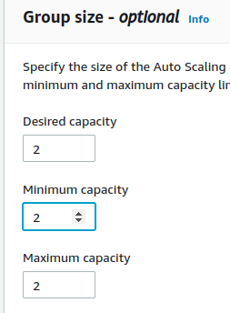

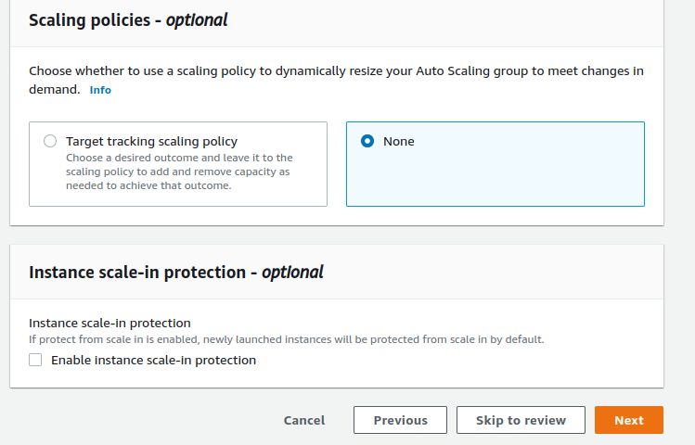

Add Tags

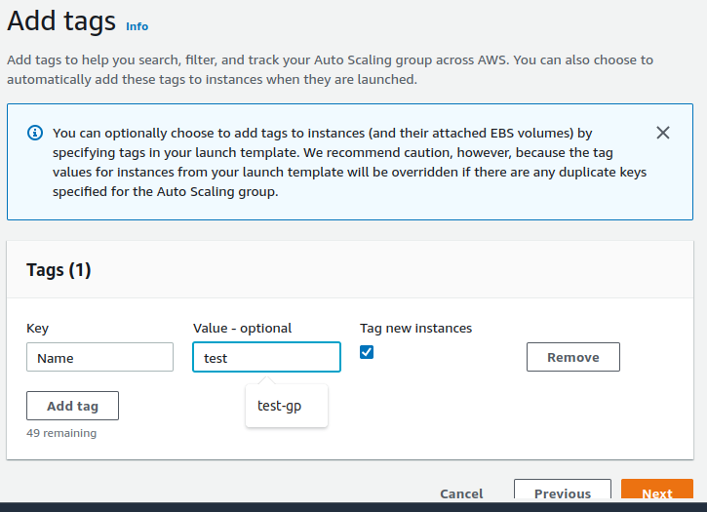

Create Auto Scaling Group



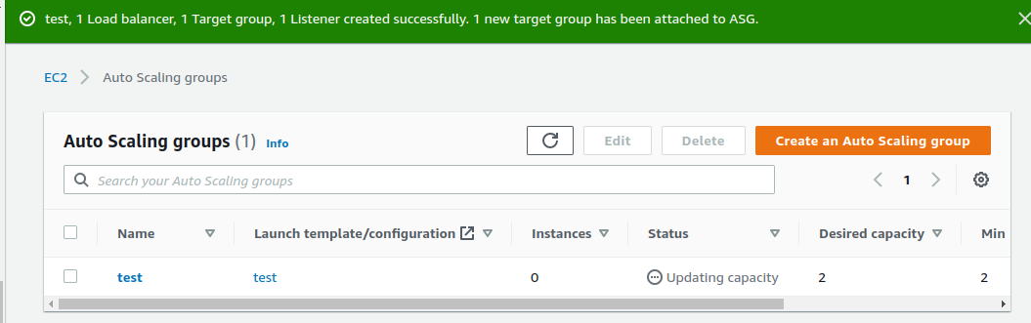

Come into EC2 DashBoard

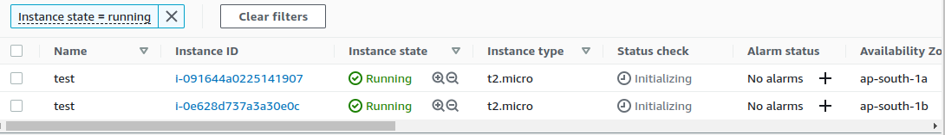

It Created Two EC2 Instance

Copy ip and paste on browser both of instance

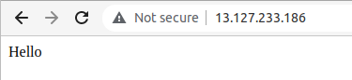

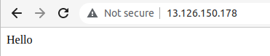

Copy load balancer DNS url and paste on browser



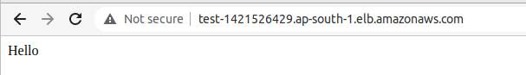

It is our version 1.0 application

<https://github.com/vishwanathacharya/blue-greencicd.git>

In this repository we have application version 1.1

Open AWS Management Console

Search CodeDeploy

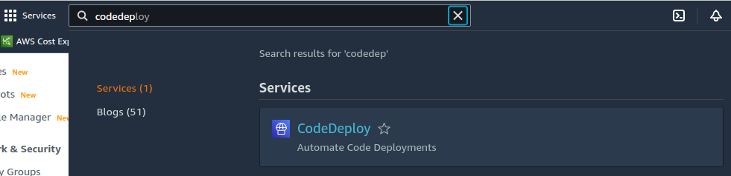

Open code deploy service

Create Application

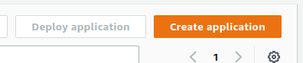

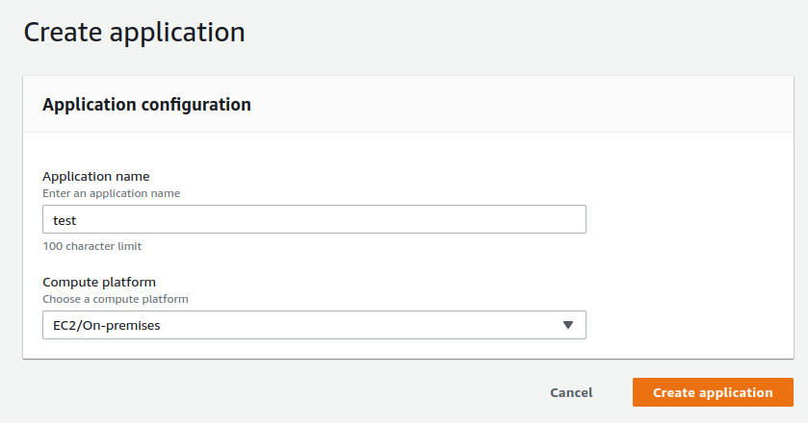

Create Deployment Group

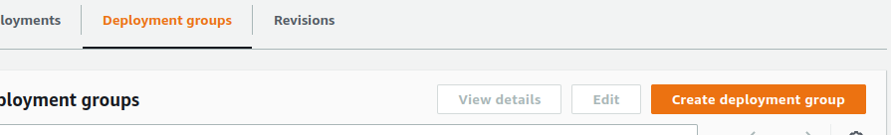

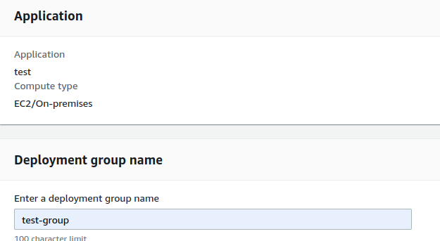

Add service Role For Code Deploy which is you Created

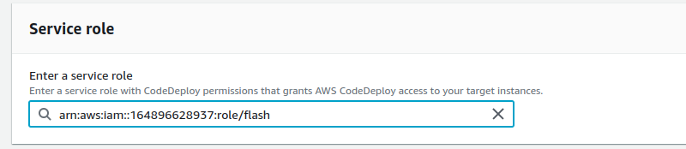

Deployment Type Blue/green

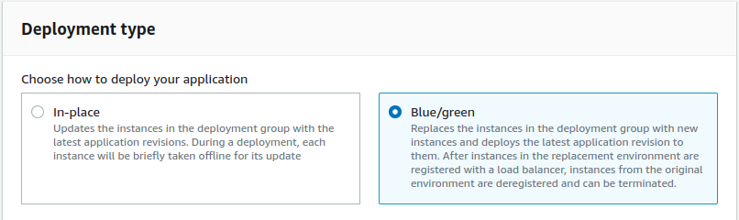

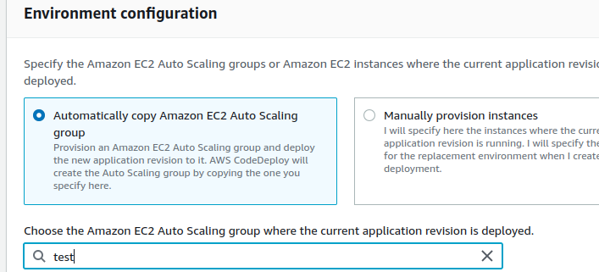

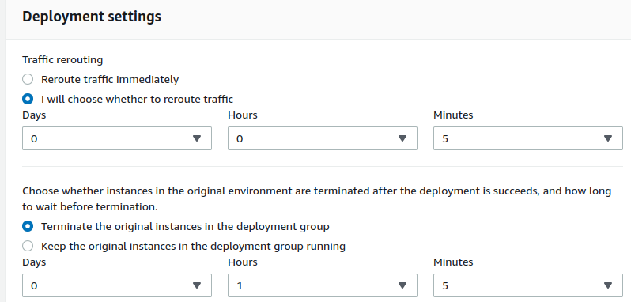

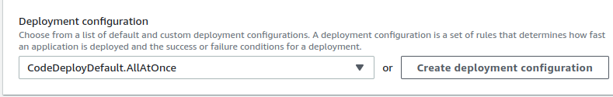

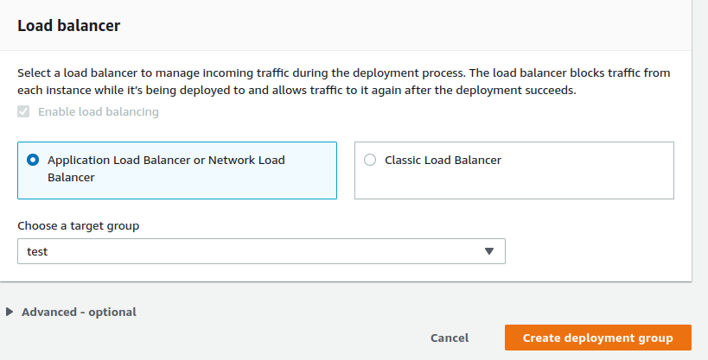

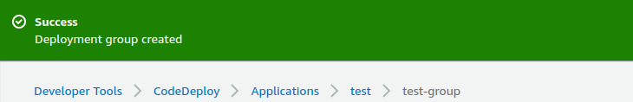

Open Pipeline

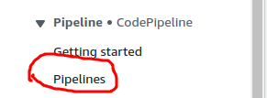

Create Pipeline

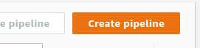

Attach Service or Add Existing Service Role

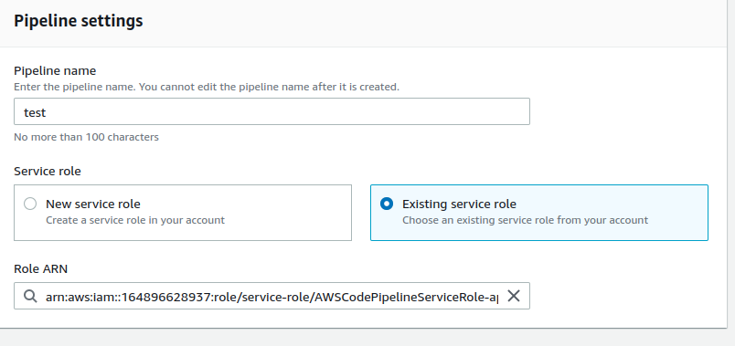

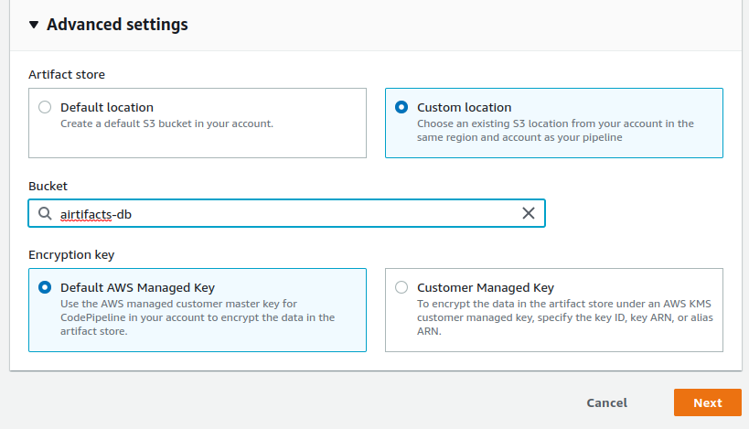

Note Create S3 Bucket to Store Artifacts

I have already Created

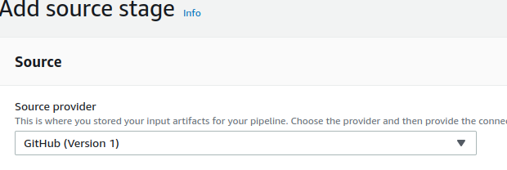

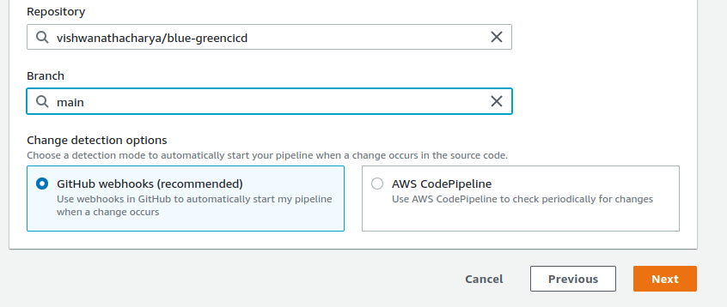

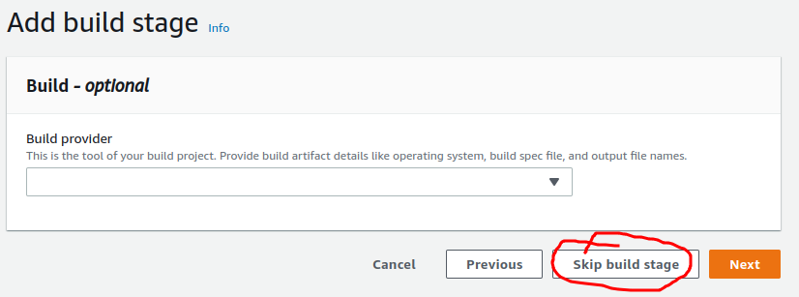

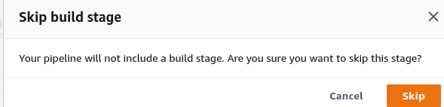

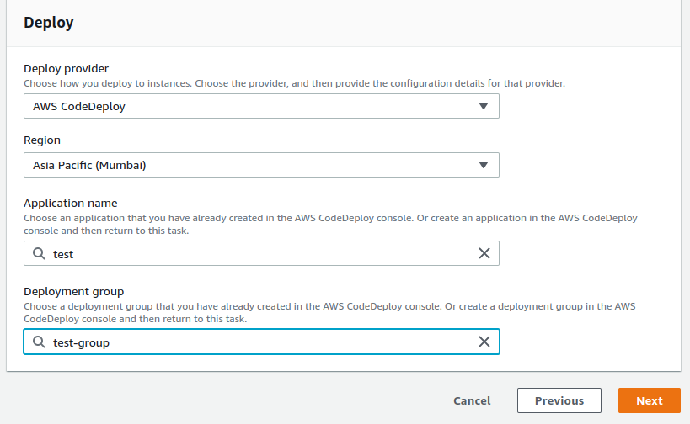



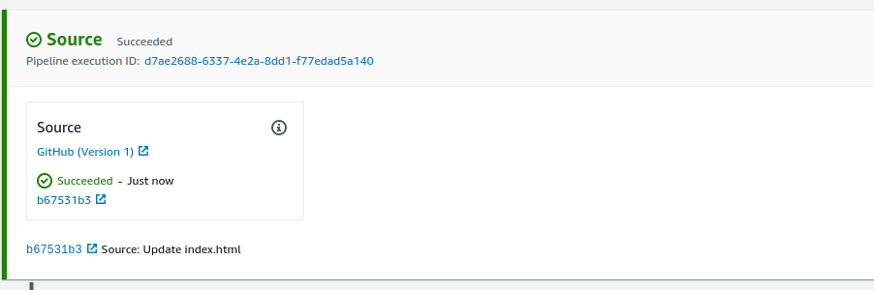

Click on detail

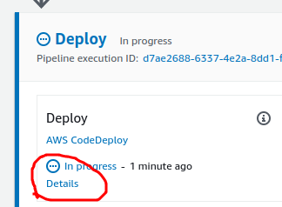

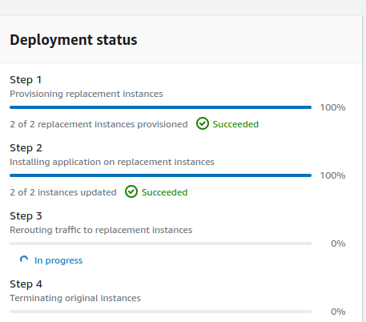

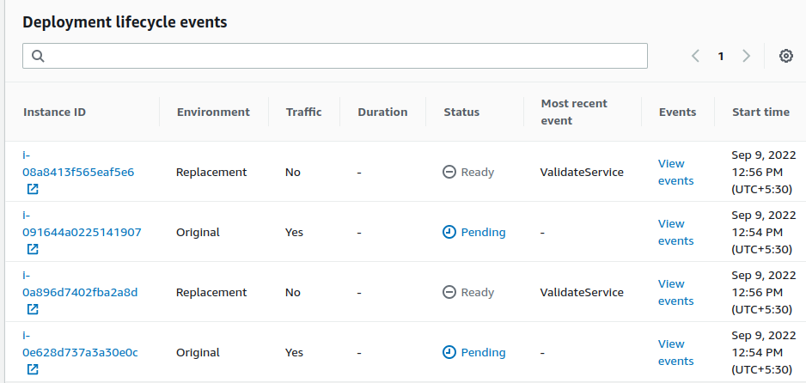

Click on Orange Reroute traffic

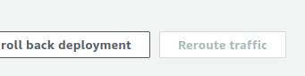

Come into ec2

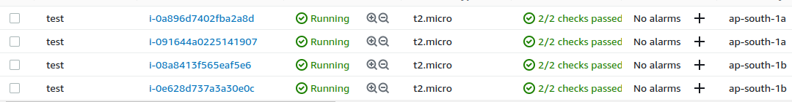

Here created For EC2

Copy Load Balancer DNS On Browser URL

